WEDE5020 POE PART 1 2023

STUDENT NAME: ISHVEER MUDHAI

STUDENT NUMBER: ST10263399

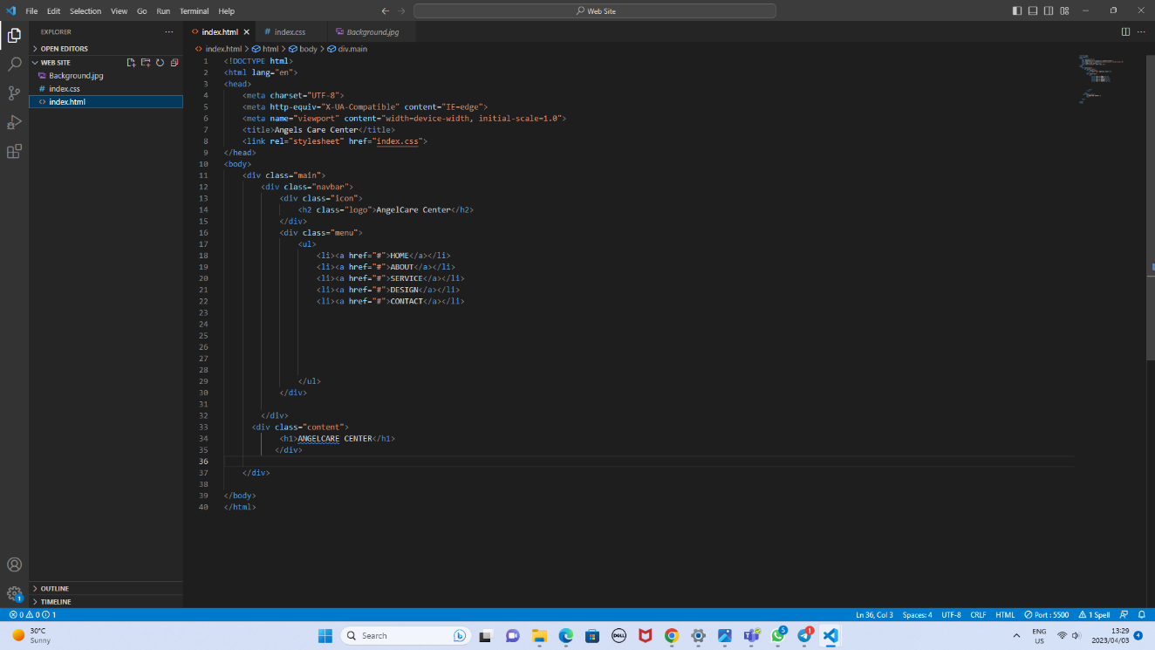

TABLE OF CONTENT

|  |  |
| --- | --- |
| Page Number | Page Content |
| 1 | Cover Page |
| 2 | Table Of Content |
| 3 | Essay |
| 4 | Graphics used in website |
| 5 | Contents of the Website  **No table of contents entries found.** |
| 6 | List of references list |
|  |  |

Essay

I have chosen to create a website for a non-government organization called Angels Care Center. I have chosen this NGO in the fight against child abuse and neglect. Child help centers inform parents, caregivers, and the public about child safety and the value of early intervention in cases of abuse or neglect throughout programs and public awareness campaigns.

Child aid centers are crucial in supporting children's rights and making sure that kids are shielded from all kinds of abuse, exploitation, and prejudice. They fight for children's rights and try to meet their fundamental needs, such as access to food, shelter, and education.

Children who have been subjected to abuse or neglect frequently feel alone and abandoned. Child aid centers offer a safe setting where kids can interact with other kids who have gone through the same things as them and feel like they belong.

Child help centers are an essential resource for children who have experienced abuse, neglect, or any form of maltreatment. The establishment of child help centers has helped to provide a safe haven for children, where they can receive medical, psychological, and emotional support.

Child help centers offer services that cater to the diverse needs of children who have experienced maltreatment. These services include counseling, medical care, legal assistance, and educational support. They provide a multidisciplinary approach to helping children heal and recover from the trauma they have experienced.

Child help centers provide a safe and supportive environment for children who have experienced abuse or neglect. They are dedicated to helping children heal from their trauma and providing them with the resources and support they need to thrive.

In conclusion, child help centers are a worthwhile topic to choose for creating a website because they are essential and preventing child abuse and neglecting, advancing children's rights, and aiding children who have been abused in their recovery.

GRAPHICS USED ON THE WEBSITE

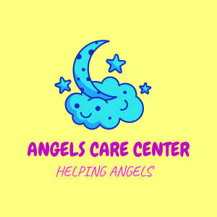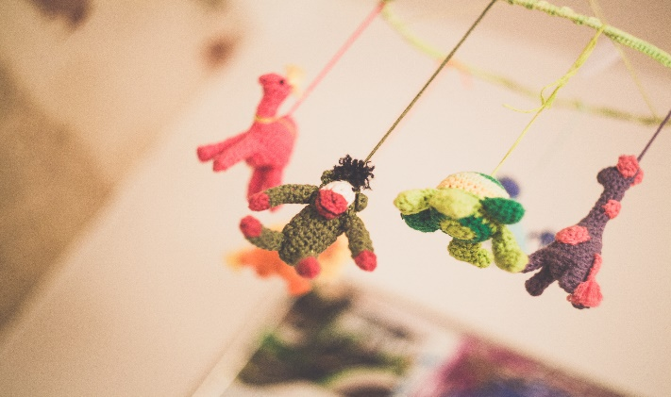

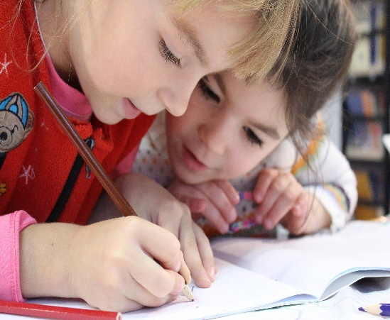

CONTENT OF WEB PAGES

HOMEPAGE:

The home page will consist of a background picture, a navigation bar with the following: Home Page, About Page, Gallery, Services, and contact page. This page will introduce what the NGO does.

ABOUT PAGE:

The About Page will consist of a background picture, and a navigation bar with the following: Home Page, About Page, Gallery, Services, and Contact page. This page will also have most of the information about the NGO.

SERVICES PAGE:

The Services Page will consist of a background picture, and a navigation bar with the following: Home Page, About Page, Gallery, Services, and Contact page. This Page will show information about all the services that we provide at the NGO

GALLERY PAGE:

The Gallery Page will consist of a background picture, and a navigation bar with the following: Home Page, About Page, Gallery, Services, and Contact page. This page will provide you with pictures of actions of the NGO.

CONTACT PAGE:

The Contact Page will consist of a background picture, and a navigation bar with the following: Home Page, About Page, Gallery, Services, and Contact page. This Page has a table of the contact details of the NGO.

List Of References List

ESSAY:

# Article: The Effects Of Early Care And Education On Children’s Health.

Author: [Taryn Morrissey](https://www.healthaffairs.org/do/10.1377/hauthor20190325.826843/full/) Publish Date: 25/04/2019 Webpage: <https://www.healthaffairs.org/do/10.1377/hpb20190325.519221>

GRAPHICS:

Author: PEXELS Publish Date: Nov 5, 2016 Webpage: <https://www.pexels.com/search/nursery%20/>

Improvements to part 1